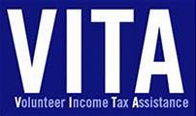
NECESSARY DOCUMENTS: What do I need to bring?
The following items are required at the time of your appointment:
- Photo ID for you (and spouse, if applicable)
- Social security or ITIN (tax ID #) cards (or photo copies) for all in family
  - not needed if prior year tax return was done by one of our tax sites (see below*) AND
you bring a copy of the tax return showing all those ITINs and social security numbers
- It is recommended that you bring a copy of prior year returns (a transcript can be ordered from the IRS at 800-908-9946). It may get you a better refund and provide for a more accurate filing.
  - If you had MN refunds, it is recommended you bring any Minnesota Department of Revenue check stubs.
- Completed IRS Intake forms included in this packet
- W-2s and any tip information
- 1099-SSA – has pink box showing total social security amount for the year before the Medicare subtraction is taken (if lost, call 877-405-3631 to obtain); can also serve as SSN verification
- 1099-INT or information from bank if less than $10 – Bank statement showing total of interest received during the year
- 1099-DIV – dividends received during the year
- 1099-R – IRA or pension retirement income for the year
- 1099-G – unemployment compensation received
- If filing for MN rent or homestead credit refund, documentation of total of nontaxable income received during the tax year, such as:
- SSI (Supplemental Security Income); if don’t have a letter showing total for tax year, go to Social Security office (206 Broadway Ave S, Suite 600 in Rochester) or call 877-405-3631 to have a letter mailed to you
- County cash assistance; if lost the letter they send in January showing the total of cash benefits received during the year, call county case worker for a copy
- Veterans Benefits
- Scholarship – also need this info on a 1098-T if want to apply for education credit
- If a homeowner, and want to file for a MN M1PR Homestead Credit Refund, income of other person living in home (unless they are a dependent or parent)
- Any other income of any kind received during the year. Front line worker pay, gambling winnings, election worker, etc
- Charitable contributions made during the year for contributions over $500 may qualify for a state deduction.
- If itemizing on federal (homeowner) – taxes paid, medical expenses, health insurance paid.
- Closing statement if bought or sold a home
- Certificate of Rent Paid forms received from landlord for current tax year
- Property tax statement for taxes payable in 2025 (if a homeowner)
- Health Insurance Information if purchased through MN Sure (need Form 1095-A)
- For direct deposit/faster refund, voided check or card/statement from bank listing routing number and account number. If none, suggest they may want to open a bank account
- Any Power of Attorney or other document giving authority to file for another

All income and expense information should be for 2024 tax year
and/or prior tax year(s) if want a return done for prior year(s)

*Tax Year 2024 Tax sites:
Salvation Army, 125 Live, Bethel Lutheran Church, Stewartville Center for Active Adults, Mantorville Senior Ctr, Sylvan Manor



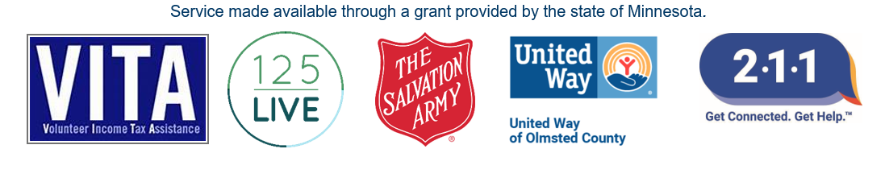
Visit VITA webpage @ semntaxes.org

